**Knee pain**

**Initial Assessment**

|  |  |  |
| --- | --- | --- |
| **Presenting Symptom/Chief Complaint** | | |
| Pain in both knees affected by cold weather. Knee feels weak(from overuse of joints) | | |
| **Main Signs and Symptoms** | | |
| Painful obstruction syndrome of the knee with local stagnation of blood and QI from overuse of joints. | | |
| **Other Signs and Symptoms** | | |
| Otherwise-healthy. | | |
| **TCM Diagnosis and Treatment (identified TCM disease, TCM differentiation of syndromes)** | | |
| Painful obstruction syndrome of the knee and local stagnation of blood and QI**.** | | |
| **Treatment Principles and Strategies** | | |
| Eliminate cold, reduce dampness, and remove obstruction from involved channel (ST channel). | | |
| **Treatment Plan (Modalities; acupuncture, herbal, dietary, manual therapies), frequency and duration** | | |
| Acupuncture-1 hour-once a week till resolving of the symptoms. | | |
| **Any other Advice Given to Patients** | | |
| Acupuncture. ST 34(bilateral) with warming needle (accumulation joints), remove obstruction.  ST36 (bilateral)-expel dampness. ST41 (bilateral), SP5 (bilateral) river point, SP9 (bilateral), LIV 7(bilateral)-relax tendos, reduce cold and dampness, LIV-8(bilateral), SP6 (bilateral)-expel dampness, nourish liver blood. | | |
| **Practitioner:** | **Date:** | **Signature:** |

**Daily Charting____________________________________Patient Name:**

**Date:**

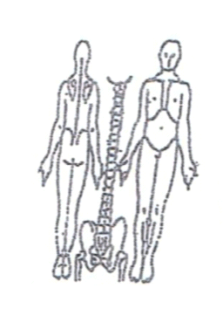 **Working Diagnosis:** Painful obstruction syndrome of the knee and local stagnation of blood and QI.

S: Chronic pain above the knee and inside the knee joint. Aggravated by walking and jogging. Sometimes swollen.

O:

Treatment (P) Acupuncture. ST 34(bilateral) with warming needle (accumulation joints), remove obstruction. ST36 (bilateral)-expel dampness. ST41 (bilateral), SP5 (bilateral) river point, SP9 (bilateral), LIV 7(bilateral)-relax tendos, reduce cold and dampness, LIV-8(bilateral), SP6 (bilateral)-expel dampness, nourish liver blood

(A) Acupancture-1 hour according to the protocol

**Date:**

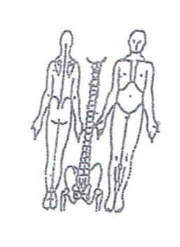**Working Diagnosis:**

S: Symptoms-the same. Pain in the both side area of the knee. Worse with

exercises at the end of the day.

O:

Treatment (P) Acupuncture 1 hour + Moxa.

(A)

**Date:**

**Working Diagnosis:**

S: Pain, walking better. Feeling more energized.

O:

Treatment (P) Acupuncture - 1hr according to the protocol.

(A)

**Date:_**

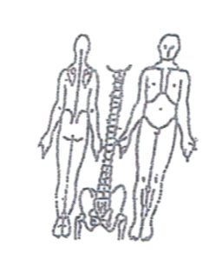**Working Diagnosis:**

S: No symptoms. No swalling. No tiredness. No pain.

O:

Treatment (P) Acupuncture -1hr. Stimulating liver and kidney.

(A)

 **Date:**

**Working Diagnosis:**

S: Feeling well. No pain. N ROM. N level of energy.

O:

Treatment (P) Acupuncture -1 hr + Moxa

(A)